Capstone Project Proposal | 
Nayef Alhunaiti

Business Goals

Project Overview and Goal  What is the industry problem you are trying to solve? Why use ML/AI in solving this task? Be as specific as you can when describing how ML/AI can provide value. For example, if you’re labeling images, how will this help the business? | Industry Problem: People struggle to maintain consistent fitness routines due to a lack of personalized guidance and motivation.  Why Use ML/AI:  - Personalized Workout Plans: AI analyses user data to create tailored workout plans, increasing satisfaction and retention.  - Real-time Feedback: AI provides instant feedback on exercise form, improving effectiveness and safety.  - Progress Tracking: AI monitors progress and sends motivational nudges, keeping users engaged.  - Nutrition Guidance: AI offers personalized diet plans that complement workouts.  Business Value: These AI-driven features enhance user experience, leading to higher subscription rates and customer loyalty, ultimately boosting revenue.
Business Case  Why is this an important problem to solve? Make a case for building this product in terms of its impact on recurring revenue, market share, customer happiness and/or other drivers of business success. | Importance: Solving the lack of personalized fitness guidance boosts user engagement and satisfaction.  Impact on Business:  - Recurring Revenue: Personalized plans and real-time feedback drive premium subscriptions and retention.  - Market Share: Unique AI features attract more users, giving a competitive edge.  - Customer Happiness: Tailored workouts and nutrition plans enhance satisfaction and motivation.  - Brand Loyalty: Satisfied users recommend the app, driving organic growth and partnerships.  This leads to increased revenue, market share, and customer loyalty.
Application of ML/AI  What precise task will you use ML/AI to accomplish? What business outcome or objective will you achieve? | - Personalized Workout Plans: Generate customized plans based on user data.  - Real-time Feedback: Provide instant exercise form corrections using computer vision.  - Progress Tracking: Monitor progress and send motivational nudges.  Business Outcome:  - Increased Engagement: Keeps users motivated.  - Higher Subscriptions: Drives premium sign-ups.  - Improved Satisfaction: Leads to happier, loyal customers.  These outcomes boost revenue, market share, and customer loyalty.

Success Metrics

Success Metrics  What business metrics will you apply to determine the success of your product? Good metrics are clearly defined and easily measurable. Specify how you will establish a baseline value to provide a point of comparison. | - User Retention Rate:  - Definition: Percentage of users who continue using the app over a specific period.  - Baseline: Measure retention rates from similar fitness apps or initial user data during the beta phase.  - Customer Satisfaction Score (CSAT):  - Definition: Average satisfaction rating from user surveys.  - Baseline: Conduct initial surveys before launching the app to establish a baseline satisfaction level.  - Subscription Conversion Rate:  - Definition: Percentage of free users who upgrade to premium subscriptions.  - Baseline: Track conversion rates during the initial launch period.  - Engagement Metrics:  - Daily Active Users (DAU): Number of users who engage with the app daily.  - Session Length: Average duration of user sessions.  - Baseline: Use initial user engagement data to set baseline values.

Data

Data Acquisition  Where will you source your data from? What is the cost to acquire these data? Are there any personally identifying information (PII) or data sensitivity issues you will need to overcome? Will data become available on an ongoing basis, or will you acquire a large batch of data that will need to be refreshed? | Data Sources:  - Wearable Fitness Devices: Data from smartwatches and fitness trackers (e.g., heart rate, steps, calories burned).  - Smartphones: User inputs and activity tracking.  - Connected Fitness Equipment: Data from treadmills, bikes, etc.  Cost:  - Integration Costs: Costs associated with integrating various data sources.  - Data Storage: Costs for storing and processing large volumes of data.  PII and Data Sensitivity:  - Compliance: Ensure compliance with GDPR and other data protection regulations.  - Anonymization: Implement data anonymization techniques to protect user privacy.  Data Availability:  - Ongoing Basis: Continuous data collection from wearables and smartphones.  - Batch Data: Periodic updates from connected fitness equipment.
Data Source  Consider the size and source of your data; what biases are built into the data and how might the data be improved? | Size and Source:  - Wearable Devices: Continuous data from smartwatches and fitness trackers.  - Smartphones: User inputs and activity tracking.  - Fitness Equipment: Periodic data from connected gym equipment.  Potential Biases:  - Demographic Bias: Overrepresentation of tech-savvy users.  - Activity Bias: More active users may skew data.  Improvement:  - Diverse Collection: Encourage varied user demographics.  - Data Augmentation: Use synthetic data to balance representation.  - Regular Audits: Monitor and adjust data collection to minimize biases.
Choice of Data Labels  What labels did you decide to add to your data? And why did you decide on these labels versus any other option? | - Exercise Type: Identifies the specific exercise.  - Duration: Records workout length.  - Intensity: Measures effort level.  - Calories Burned: Estimates energy expenditure.  - Heart Rate: Tracks cardiovascular activity.  - User Feedback: Collects ratings on workout difficulty and satisfaction.  Reasons:  - Personalization: Tailors workout plans to user preferences.  - Progress Tracking: Monitors improvements and adjusts plans.  - Safety and Effectiveness: Ensures workouts are challenging yet safe.  - User Insights: Provides valuable feedback for continuous improvement.

Model

Model Building  How will you resource building the model that you need? Will you outsource model training and/or hosting to an external platform, or will you build the model using an in-house team, and why? | - In-house Team: We will build the model using an in-house data science team.  Reasons:  - Control and Customization: Developing in-house allows for greater control over the model’s design and customization to meet specific needs.  - Data Privacy: Ensures that sensitive user data remains secure and compliant with privacy regulations.  - Expertise: Leverages internal expertise to fine-tune the model and continuously improve its performance.
Evaluating Results  Which model performance metrics are appropriate to measure the success of your model? What level of performance is required? | - Accuracy: Aim for at least 90% to ensure reliable recommendations.  - Precision and Recall: Both should be above 85% to balance relevance and comprehensiveness.  - F1 Score: Target a score above 0.85 to maintain a good balance between precision and recall.

Minimum Viable Product (MVP)

Design  What does your minimum viable product look like? Include sketches of your product. | - Personalized Workout Plans: Tailored exercise routines based on user data.  - Real-time Feedback: Instant corrections and suggestions during workouts.  - Progress Tracking: Visualizations of user progress over time.  - Nutrition Guidance: Personalized diet plans that complement workout routines.  Sketches of the Product:  - Dashboard:  - Overview of daily activities, progress, and upcoming workouts.  - 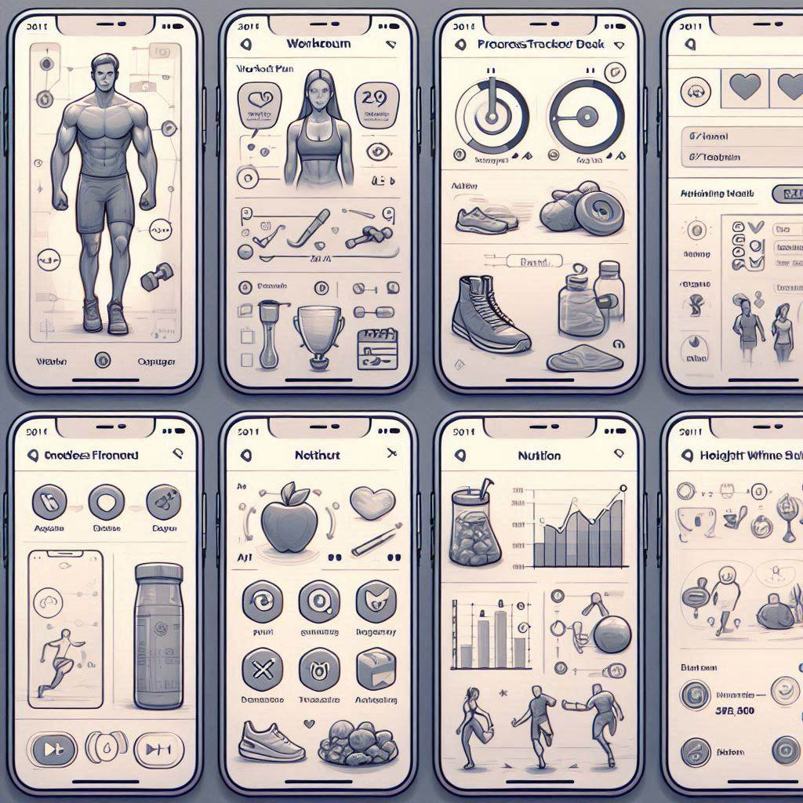  - Workout Plan:  - Detailed exercise routines with instructions and real-time feedback.  - 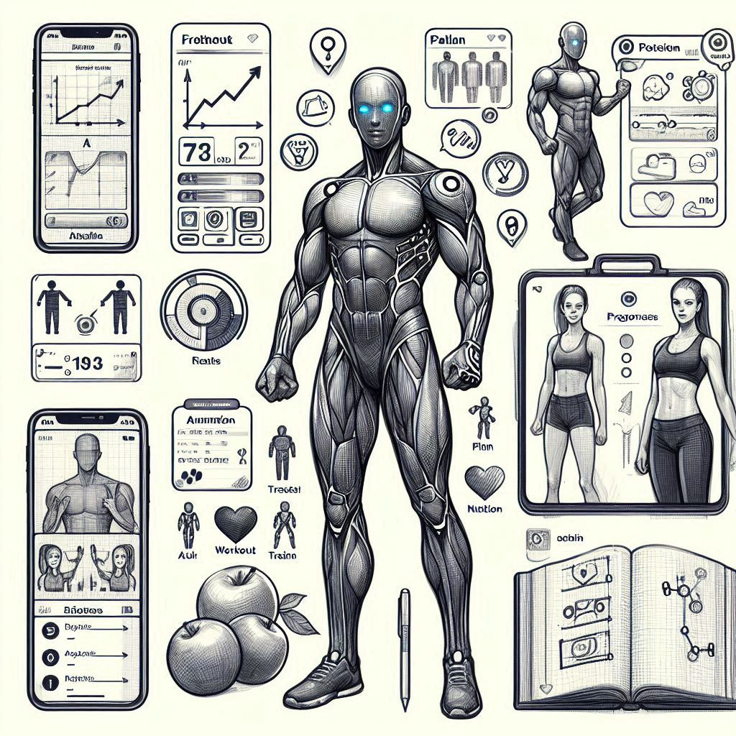  - Progress Tracker:  - Graphs and charts showing progress in various fitness metrics.  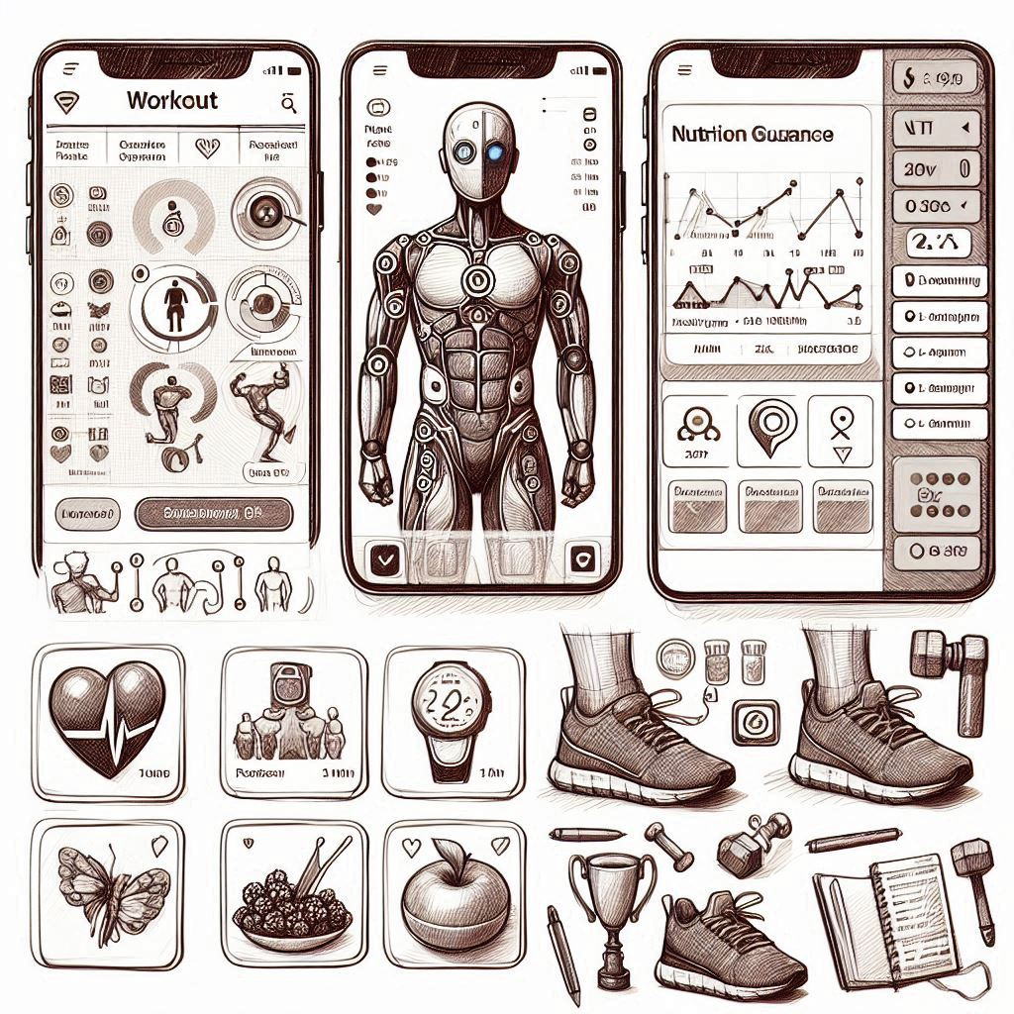  - Nutrition Guidance:  Personalized meal plans and dietary recommendations.  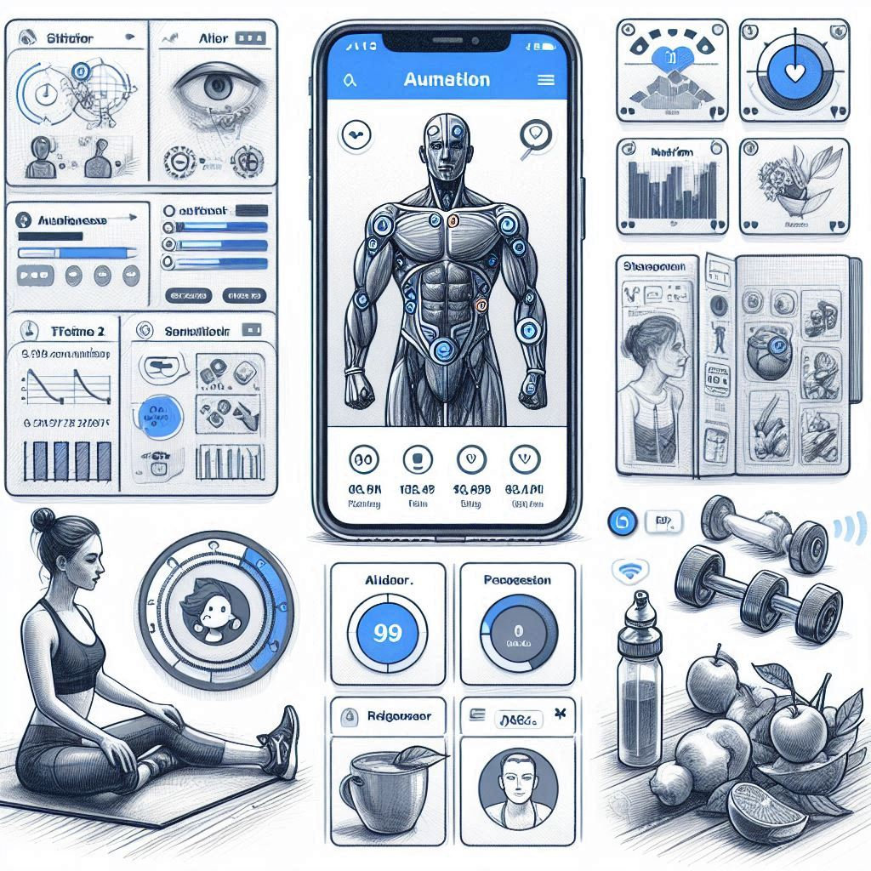
Use Cases  What persona are you designing for? Can you describe the major epic-level use cases your product addresses? How will users access this product? | - Fitness Enthusiast:  - Description: Regularly exercises, seeks advanced workout plans, and tracks progress meticulously.  - Goals: Improve performance, achieve specific fitness milestones, and maintain a healthy lifestyle.  - Beginner:  - Description: New to fitness, needs basic guidance and motivation to start and maintain a routine.  - Goals: Learn proper exercise techniques, build a consistent workout habit, and improve overall health.  - Specific Goals User:  - Description: Has specific fitness goals such as weight loss, muscle gain, or training for an event.  - Goals: Achieve targeted fitness outcomes through personalized plans and progress tracking.  Major Epic-Level Use Cases:  - Personalized Workout Plans:  - Epic: As a user, I want to receive workout plans tailored to my fitness level, goals, and preferences so that I can achieve my fitness objectives effectively.  - Access: Users input their fitness data and preferences into the app, which then generates a customized workout plan.  - Real-time Feedback:  - Epic: As a user, I want to receive real-time feedback on my exercise form and technique to ensure I am performing exercises correctly and safely.  - Access: Users perform exercises while the app uses computer vision to provide instant feedback and corrections.  - Progress Tracking:  - Epic: As a user, I want to track my fitness progress over time with visualizations and insights to stay motivated and see my improvements.  - Access: Users log their workouts and the app automatically tracks and displays progress through graphs and charts.  - Nutrition Guidance:  - Epic: As a user, I want to receive personalized nutrition plans that complement my workout routine to optimize my fitness results.  - Access: Users input dietary preferences and restrictions, and the app provides tailored meal plans and recommendations.  Access:  - Mobile App: Users can access the product through a mobile app available on iOS and Android platforms.  - Web Application: Users can also access the product via a web application for convenience and broader accessibility.
Roll-out

How will this be adopted? What does the go-to-market plan look like?

Post-MVP-Deployment

Designing for Longevity  How might you improve your product in the long-term? How might real-world data be different from the training data? How will your product learn from new data? How might you employ A/B testing to improve your product? | - Beta Testing:  - Invite Early Adopters: Select a group of fitness enthusiasts and beginners to test the app.  - Gather Feedback: Collect user feedback to refine features and fix any issues.  - Soft Launch:  - Limited Release: Launch the app in a specific region or to a limited audience.  - Monitor Performance: Track key metrics and user engagement to ensure stability and effectiveness.  - Full Launch:  - Global Availability: Release the app on iOS and Android platforms worldwide.  - Marketing Campaign: Implement a comprehensive marketing strategy to promote the app.  Go-to-Market Plan:  - Marketing Channels:  - Social Media: Utilize platforms like Instagram, Facebook, and TikTok to reach fitness enthusiasts.  - Influencer Partnerships: Collaborate with fitness influencers to promote the app.  - Content Marketing: Create engaging content such as blog posts, videos, and tutorials.  - Promotional Offers:  - Free Trials: Offer a free trial period for premium features to attract new users.  - Referral Programs: Encourage existing users to refer friends and earn rewards.  - Partnerships:  - Fitness Brands: Partner with fitness equipment and apparel brands for cross-promotion.  - Gyms and Fitness Centers: Collaborate with gyms to offer exclusive app features to their members.  - Customer Support:  - Help Center: Provide a comprehensive help center with FAQs and tutorials.  - Live Support: Offer live chat support to assist users with any issues.  - Continuous Improvement:  - Regular Updates: Release regular updates with new features and improvements based on user feedback.  - User Engagement: Maintain high user engagement through personalized notifications and challenges.
Monitor Bias  How do you plan to monitor or mitigate unwanted bias in your model? | - Diverse Data: Use a representative dataset to avoid sampling bias.  - Fairness Metrics: Evaluate fairness using metrics like demographic parity and equalized odds.  - Bias Detection Tools: Utilize tools like AI Fairness 360 and Fairlearn.  - Model Interpretability: Apply techniques like SHAP and LIME to understand model decisions.  - Bias Mitigation: Implement pre-processing, in-processing, and post-processing techniques.  - Continuous Monitoring: Regularly audit your model and gather user feedback.

